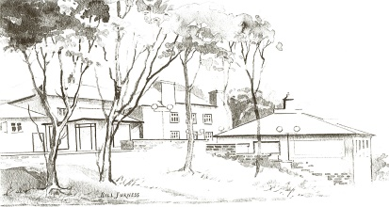
RYDINGS HALL SURGERY
CHURCH LANE
BRIGHOUSE
HD6 1AT
Tel: 01484 715324
Dr A Wilkinson – Dr V L Odell – Dr R Bakashi – Dr C J Bouchard – Dr M Gatenby

www.rydingshallsurgery.org.uk

COMPLAINT FORM
Complainants Details

Full Name: ___________________________ Date of Birth:____________

Address: _________________________________________________________

Patient Details (Where different from above)

Full Name:________________________________ Date of Birth:____________

Address: ___________________________________________________________________

Please note that you have to respect our duty of confidentiality to patients, a patient’s consent will be necessary if you are complaining on their behalf (over 16yrs of age). They will need to complete a complaint authorisation form.

Details of complaint (including date(s) of events and persons involved)

Complainant’s Signature:______________________ Date:________________

